**Content**

1. .gitlab-ci.yml 2

1. Artifacts, what are artifacts? 3

1. .gitlab-ci.yml

This is a convention, gitlab will automatically recognize the file.

Once you’ve added your .gitlab-ci.yml configuration file to your repository, GitLab will detect it and run your scripts with the tool called **GitLab Runner**, which works similarly to your terminal.

The scripts are grouped into jobs, and together they compose a pipeline. A minimalist example of .gitlab-ci.yml file could contain:

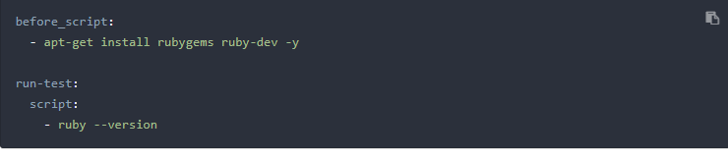

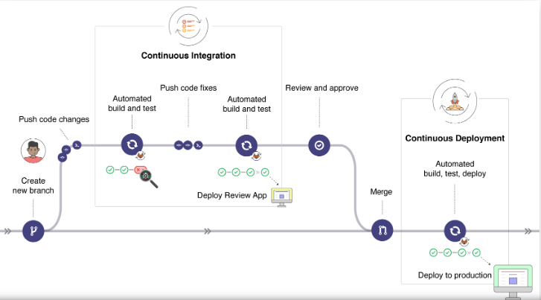

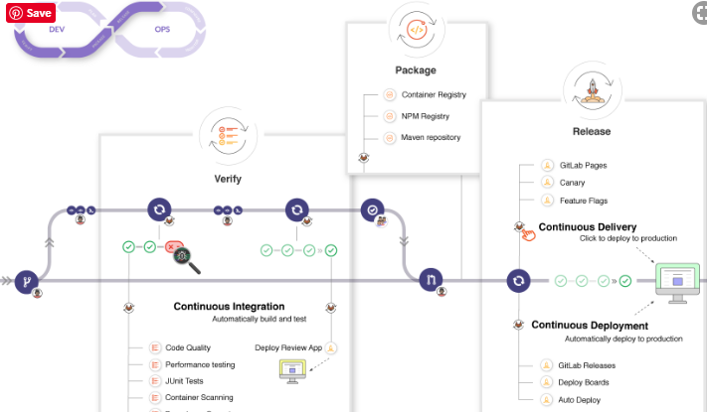

* 1. Artifacts, what are artifacts?